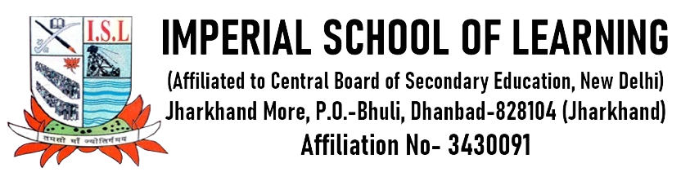

LIST OF SCHOOL MANAGEMENT COMMITTEE (SMC)

Sl. No. Name Designation in SMC Address Phone
01 Mrs. Jyoti Sharma Principal Kola Kusuma, Dhanbad 8409158662
02 Mrs Anjali Das Teachers representative Bhuli, E-Block, Dhanbad 9431553320
03 Mr. Mahendra Rawani Teachers representative Katrash, Dhanbad 9939201274
04 Mr. Kaushal Kumar Parents Representative Rangatand, Dhanbad 7061954019
05 Mrs. Urmila Singh Parents Representative Jharkhand More, Bhuli, Dhanbad ***********
06 Mr. H. K. Thakur Member Sindri, Dhanbad 9304715973
07 Mrs. Pinki Singh Member Bokaro, Dhanbad 8285718548
08 Mrs Kaushalya Bose Member Bastakola, Dhanbad 9304143470
09 Mrs. Madhuri Prasad Member Combined Building, Dhanbad 9431726745
10 Mr. Mukesh Kumar Member Principal, Central School-2, Jagjiwan Nagar, Dhn. 0326-2210705
11 Mr. Shailendra Sharma Member Principal, Central School-1, Binod Nagar, Dhn. 0326-2310551

